Aerosmith Maze

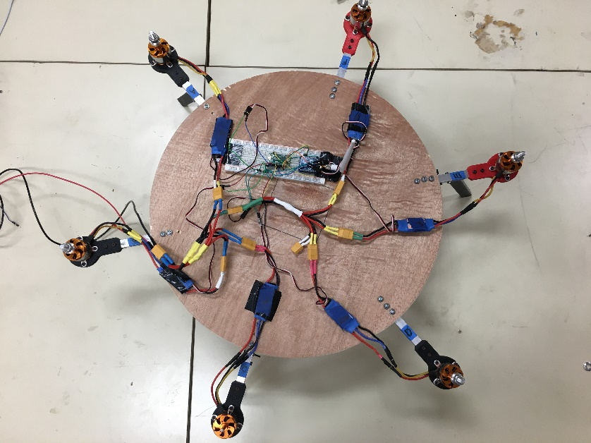Diameter: 48 cm

Thickness: 1.2 cm

Materials

1 Round piece of wood

6 Turnigy Aerodrives motors (D3536/9 910KV)

6 Electronic Speed controllers (Hobby King 30A UBEC)

1 power supply (BK precision 1900)